

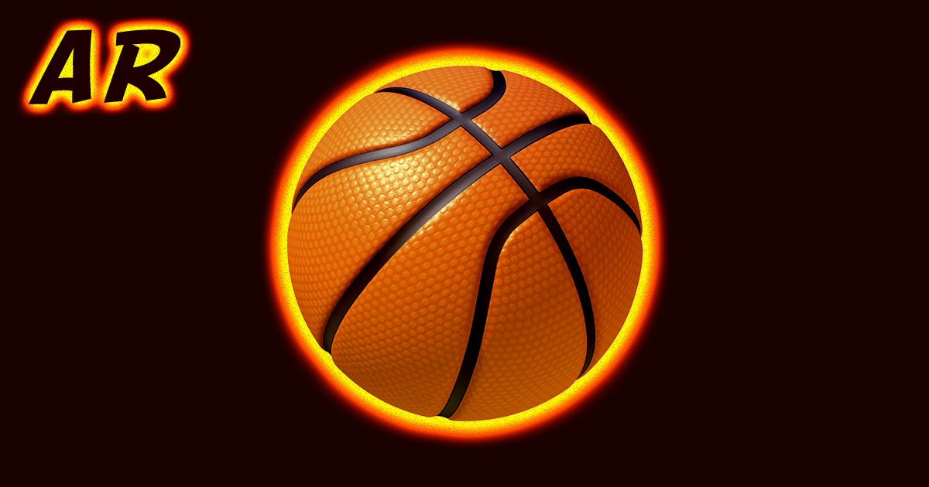

­

AR Basketball GO

Contents

REMEMBER 3

INTRO 4

MANUAL 5

$ 5

Ball 5

GyroCamera & GameWorld 5

# REMEMBER

• If you like this asset, please rate and/or review it on the asset store, every rating

is useful to help us to improve this plugin.

• If you find a bug or you can’t use asset as you need, please first [send us an email to info@makaka.org](mailto:info@makaka.org?subject=%255BAR%20Basketball%20GO%255D%20Question) (in English or in Russian) before leaving a negative review to the asset store. We are here to help and to improve our plugin for the best.

# INTRO

*Note: The camera implements markerless augmented reality, using the gyroscope like Pokemon GO. It's easy to set up the asset for marker-based AR like Vuforia.*

AR Basketball GO - simple arcade for mobile platforms with realistic physics of a basketball net and hoop.

Tested with iOS 10.2 on iPhone 6.

Tested with Android 6.0 on Samsung Galaxy S7.

All modules are designed independently to keep this asset extendable & easy to understand.

# MANUAL

## $

Almost every scene has "$" GameObject, which has main control scripts for the scene.

Through the "$" various modules interact with each other.

## Ball

Main GameObject. You can setup throw settings in the editor.

## GyroCamera & GameWorld

The Main Camera has a script (GyroCamera.cs), which refers to the GameWorld.

Place inside GameWorld all objects you want to see in Augmented Reality.